- Once your SignalGenUtility- Project is built (see other documentation), we can go ahead and run it!

- In a WSL, navigate to your folder containing the popoto_app. For the transmit side, specify the port number as 17000. For the receiving side, specify the port number as 17100.
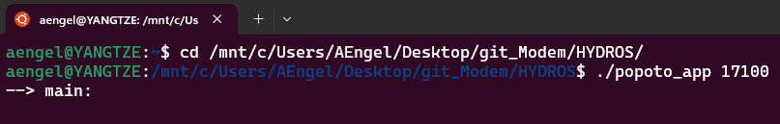

- Plug in an NI card to your PC/laptop. If you don’t have NI Max installed, do that riiiiight now. Unfortunately it takes forever. Once NI Max is installed, you should see your plugged in NI cards here:
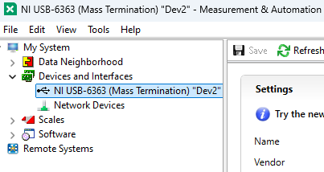

- The program will default to the NI card you have plugged in. If you have multiple cards plugged in, you will have an option to select which one you would like to use. If no NI card is present (turned on & plugged in), you will see this message when you run the program:
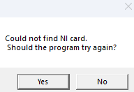

- Assuming you have connected to an NI card, and have an instance of the modem running (with the right port number), the application will load as below. At this time, the modem has already been fed the ‘startrx’ command, and set the Carrier frequency to 35kHz:
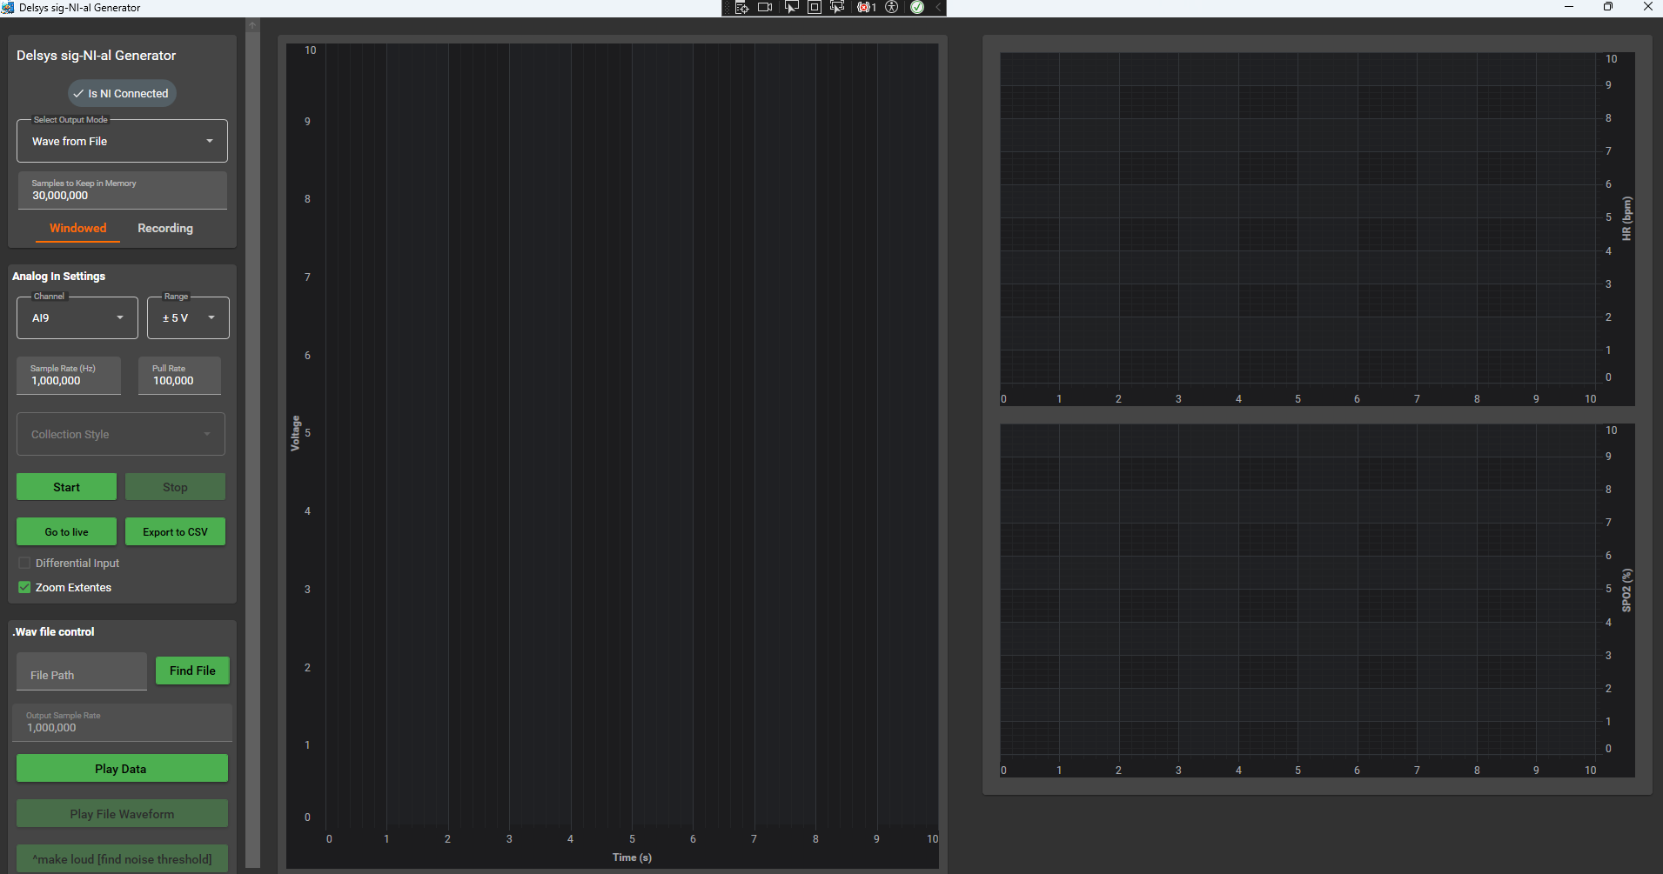

- The “Samples to Keep in Memory” specifies how many points are saved in memory at any given moment. This will be evident by how many points you can see on the graph as well.

- In the ‘Windowed’ tab, the program probably works how you expect, with a continuous updating of the samples in memory. In the ‘Recording’ tab, the samples in memory get updated once per second. Additionally, these points get saved to a csv:
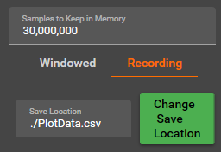
- Click the “Play Data” button to start either encoding or decoding waveforms (depending on your project). The signal going across the water is sent at 1MHz, and is upsampled/downsampled before/after being sent across the water, since the modem sends/receives waveforms at 102.4kHz sampling frequency. This again depends on the project you are running.
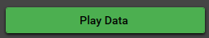

- To play a file, first select a .wav file using the “Find File” button. Make sure to update the sample rate in the Analog In controls to match the file. (The pull rate will update automatically). Then select “Play File Waveform”. This will play the file 1 time, then stop.
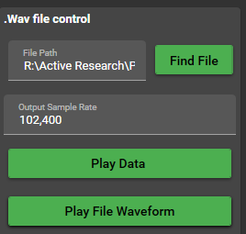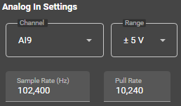

- In this project, most of the relevant code is contained in the DelsysSignNIalGen project. This project should be the only one you have to modify.

- The physical screen & buttons that you can see in the application are controlled under View/MainView.xaml. When the application is not running, viewing the file will show you the following:
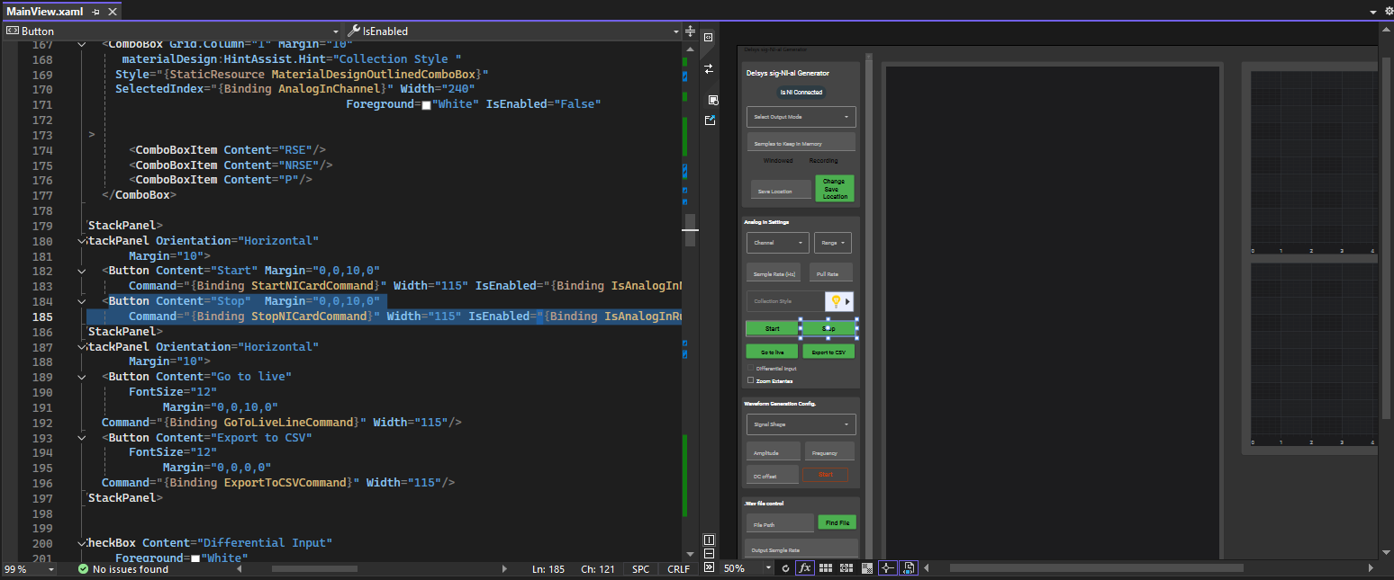
- If you want to see what the ‘Stop’ button does, for example, simply click on the Stop button. This will highlight where this button is specified in the ‘code behind’. Now you can see the command it calls is ‘StopNICardCommand’. Therefore, you can see what this button does by looking at the ‘StopNICard’ function in MainViewModel.cs.
- You can also click on the plotting surfaces to see how they are defined.

- In terms of hardware, the AO0 port is the default analog out port. You will need to search for this port number in the code to change it, if you intend to use a different port number. I specified 9, as the analog in port, in the MainView.xaml, but it can still be toggled on the main screen.

- In MainViewModel.cs, every button’s functionality is specified. Any necessary Blocking Collections and/or thread management is handled here. You can also see the Consumer architecture here.

- In ModemProgram.cs, the modem connection is initialized, the waveforms are encoded/decoded and upsampled/downsampled, and all modem communication is handled.

- In ValuePlots.cs, there is some simple code for creating two line plots. These plots show the decoded values. One for hr, and one for spo2. LineRenderableSeries1 and LineRenderableSeries2 are referenced by MainView.xaml for plotting.

- Other features:
- In MainViewModel.cs, I specify that the plot shows 10 seconds of data at a time, here: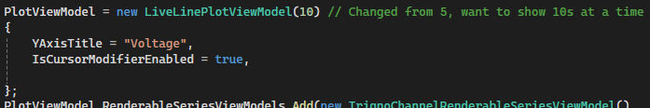
- In ModemProgram.cs, ‘trialNum’ determines the outputLog.txt file name (only relevant on the receive side). When the program is stopped & started, this number will increment. But when completely re-running the program, this number will need to be manually changed. The secretCarrierFrequency is the carrier frequency that goes across the water. It will need to be the same on the transmit & receive ends, for decoding to work.
- In MainObservableProperties.cs, the default location for the continuously recorded waveform to export to can be set.
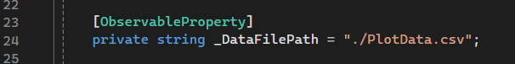

Please reach out to me, if you have any questions!
- Anna Engel
- AEngel@delsys.com
- anna.c.engel@gmail.com

